

SIMPLE E-COMMERCE PLATFORM

A PROJECT REPORT
Submitted by

NEHA HENIN J (2303811714822025)

in partial fulfillment of requirements for the award of the course
CGB1221-DATABASE MANAGEMENT SYSTEMS
in

ARTIFICIAL INTELLIGENCE AND MACHINE LEARNING

K. RAMAKRISHNAN COLLEGE OF TECHNOLOGY
(An Autonomous Institution, affiliated to Anna University Chennai and Approved by AICTE, New Delhi)

SAMAYAPURAM – 621 112

JUNE- 2025

K. RAMAKRISHNAN COLLEGE OF TECHNOLOGY
(AUTONOMOUS)
SAMAYAPURAM – 621 112

BONAFIDE CERTIFICATE

Certified that this project report on “Payroll Management System” is the bonafide work of NEHA HENIN J(2303811714822025) who carried out the project work during the academic year 2024 - 2025 under my supervision.

SIGNATURE  Dr.T.AVUDAIAPPAN, M.E.,Ph.D.,  HEAD OF THE DEPARTMENT  ASSOCIATE PROFESSOR  Department of Artificial Intelligence  K.Ramakrishnan College of Technology (Autonomous)  Samayapuram–621112. | SIGNATURE  Mr.R.ROSHAN JOSHUA, M.E.,  SUPERVISOR  ASSISTANT PROFESSOR  Department of Artificial Intelligence  K.Ramakrishnan College of Technology (Autonomous)  Samayapuram–621112.

Submitted for the viva-voce examination held on …04.06.2025……………….

INTERNAL EXAMINER | EXTERNAL EXAMINER
DECLARATION

I declare that the project report on “Simple E-commerce Platform” is the result of original work done by us and best of our knowledge, similar work has not been submitted to “ANNA UNIVERSITY CHENNAI” for the requirement of Degree of BACHELOR OF ENGINEERING. This project report is submitted on the partial fulfilment of the requirement of the completion of the course CGB1221 – DATABASE MANAGEMENT SYSTEMS.

Signature

Name of the Student

Place: Samayapuram

Date:04/06/20025

ACKNOWLEDGEMENT

It is with great pride that I express our gratitude and in-debt to our institution “K.Ramakrishnan College of Technology (Autonomous)”, for providing us with the opportunity to do this project.

I glad to credit honourable chairman Dr. K. RAMAKRISHNAN, B.E., for having provided for the facilities during the course of our study in college.

I would like to express our sincere thanks to our beloved Executive Director Dr. S. KUPPUSAMY, MBA, Ph.D., for forwarding to our project and offering adequate duration in completing our project.

I would like to thank Dr. N. VASUDEVAN, M.Tech., Ph.D., Principal, who gave opportunity to frame the project the full satisfaction.

I whole heartily thanks to Dr. T. AVUDAIAPPAN, M.E.,Ph.D., Head of the department, ARTIFICIAL INTELLIGENCE for providing his encourage pursuing this project.

I express our deep expression and sincere gratitude to our project supervisor Mr.R.ROSHAN JOSHUA, M.E., Department of ARTIFICIAL INTELLIGENCE, for his incalculable suggestions, creativity, assistance and patience which motivated us to carry out this project.

I render our sincere thanks to Course Coordinator and other staff members for providing valuable information during the course.

I wish to express our special thanks to the officials and Lab Technicians of our departments who rendered their help during the period of the work progress.

INSTITUTE
Vision:
- To serve the society by offering top-notch technical education on par with global standards.
Mission:
- Be a center of excellence for technical education in emerging technologies by exceeding the needs of industry and society.
- Be an institute with world class research facilities.
- Be an institute nurturing talent and enhancing competency of students to transform them as all – round personalities respecting moral and ethical values.

DEPARTMENT
Vision:

- To become a renowned hub for AIML technologies to producing highly talented globally recognizable technocrats to meet industrial needs and societal expectation.

Mission

- To impart advanced education in AI and Machine Learning, built upon a foundation in Computer Science and Engineering.
- To foster Experiential learning equips students with engineering skills to tackle real-world problems.
- To promote collaborative innovation in AI, machine learning, and related research and development with industries.
- To provide an enjoyable environment for pursuing excellence while upholding strong personal and professional values and ethics.

PROGRAM EDUCATIONAL OBJECTIVES (PEO)

- PEO1: Excel in technical abilities to build intelligent systems in the fields of AI & ML in order to find new opportunities.
- PEO2: Embrace new technology to solve real-world problems, whether alone or as a team, while prioritizing ethics and societal benefits.
- PEO3: Accept lifelong learning to expand future opportunities in research and product development.

PROGRAM SPECIFIC OUTCOMES (PSO)
- PSO1: Expertise in tailoring ML algorithms and models to excel in designated applications and fields.
- PSO2: Ability to conduct research, contributing to machine learning advancements and innovations that tackle emerging societal challenges.

PROGRAM OUTCOMES (POs)
Engineering students will be able to:
- Engineering knowledge: Apply the knowledge of mathematics, science, engineering fundamentals, and an engineering specialization to the solution of complex engineering problems.
- Problem analysis: Identify, formulate, review research literature, and analyze complex engineering problems reaching substantiated conclusions using first principles of mathematics, natural sciences, and engineering sciences
- Design/development of solutions: Design solutions for complex engineering problems and design system components or processes that meet the specified needs with appropriate consideration for the public health and safety, and the cultural, societal, and environmental considerations
- Conduct investigations of complex problems: Use research-based knowledge and research methods including design of experiments, analysis and interpretation of data, and synthesis of the information to provide valid conclusions
- Modern tool usage: Create, select, and apply appropriate techniques, resources, and modern engineering and IT tools including prediction and modeling to complex engineering activities with an understanding of the limitations
- The engineer and society: Apply reasoning informed by the contextual knowledge to assess societal, health, safety, legal and cultural issues and the consequent responsibilities relevant to the professional engineering practice
- Environment and sustainability: Understand the impact of the professional engineering solutions in societal and environmental contexts, and demonstrate the knowledge of, and need for sustainable development
- Ethics: Apply ethical principles and commit to professional ethics and responsibilities and norms of the engineering practice.
- Individual and team work: Function effectively as an individual, and as a member or leader in diverse teams, and in multidisciplinary settings.
- Communication: Communicate effectively on complex engineering activities with the engineering community and with society at large, such as, being able to comprehend and write effective reports and design documentation, make effective presentations, and give and receive clear instructions.
- Project management and finance: Demonstrate knowledge and understanding of the engineering and management principles and apply these to one’s own work, as a member and leader in a team, to manage projects and in multidisciplinary environments.
- Life-long learning: Recognize the need for, and have the preparation and ability to engage in independent and life-long learning in the broadest context of technological change.

ABSTRACT

The Payroll Management System is a robust and efficient software application developed to automate and streamline all aspects of payroll processing within an organization. It is designed to manage complex payroll functions including salary calculations, tax deductions, benefits administration, and statutory compliance with minimal human intervention. By integrating with attendance and leave management modules, the system ensures accurate computation of salaries based on employee working hours, overtime, leaves taken, and applicable deductions.
The system maintains a centralized database containing employee details such as personal information, job roles, salary structures, bank details, and employment history. Through this comprehensive data management, the system supports consistent and transparent payroll operations. It enables organizations to define salary components, set rules for allowances and deductions, and apply them automatically during payroll runs, reducing the risk of errors and inconsistencies.
Furthermore, the Payroll Management System facilitates the automatic calculation of taxes and statutory contributions such as provident fund, employee state insurance, and professional tax, ensuring compliance with government regulations. Payslips are generated and made available to employees in a secure and timely manner. The system also provides powerful reporting features, allowing administrators to generate detailed reports on payroll summaries, tax filings, and employee earnings, which aids in strategic planning and audit processes.
Developed using modern software technologies, the system is designed for scalability, data security, and ease of use. It supports multiple user roles with varying access levels, ensuring that sensitive payroll information is protected and accessible only to authorized personnel. The implementation of this system significantly reduces administrative workload, enhances payroll accuracy, improves employee satisfaction, and contributes to the overall operational efficiency of the organization.

ABSTRACT WITH POs AND PSOs MAPPING

CO 5 : BUILD DATABASES FOR SOLVING REAL-TIME PROBLEMS.
ABSTRACT | POs MAPPED | PSOs MAPPED
In the digital era, e-commerce platforms play a vital role in transforming traditional shopping methods into seamless online experiences. This project focuses on designing and implementing a simple yet functional e-commerce database system to manage real-time operations such as product listing, customer registration, order processing, and transaction management. The system is built using a relational database management system (RDBMS), emphasizing database normalization, integrity constraints, and SQL-based CRUD operations.  The platform consists of multiple interrelated entities such as Customers, Products, Orders, Payments, and Categories, modeled using Entity-Relationship Diagrams (ERDs). The database supports essential functionalities including searching products, placing orders, tracking deliveries, and managing user accounts. It ensures data consistency, concurrency, and secure access control.  This project demonstrates how a well-structured database can support the core functionalities of an e-commerce system, enabling scalability and efficiency. It also incorporates concepts of indexing, stored procedures, and transaction control to enhance performance and reliability. | PO1 -3  PO2 -3  PO3 -3  PO4 -3  PO5 -3  PO6 -3  PO7 -3  PO8 -3  PO9 -3  PO10 -3  PO11-3  PO12 -3 | PSO1 -3  PSO2 -3  PSO3 -3
Note: 1- Low, 2-Medium, 3- High

TABLE OF CONTENTS
CHAPTER NO. | TITLE | PAGE NO.
 | ABSTRACT
1 | INTRODUCTION
 | 1.1 Objective
 | 1.2 Overview
 | 1.3 SQL and Database concepts
2 | PROJECT METHODOLOGY
 | 2.1 Proposed Work
 | 2.2 Block Diagram
3 | MODULE DESCRIPTION
 | 3.1 3.1 User Management Module
 | 3.2 Product Management Module
 | 3.3 Cart and Order Module
 | 3.4 Payment Module
 | 3.5 Admin Module
4 | CONCLUSION & FUTURE SCOPE
5 | APPENDIX A SOURCE CODE
 | APPENDIX B SCREENSHOTS
 | REFERENCES

CHAPTER 1: INTRODUCTION

  - Objective.
The objective of this project is to develop a robust, reliable, and user-friendly Payroll Management System that efficiently manages and automates the payroll processes of an organization. The system is designed to address the challenges of manual payroll handling, such as human error, delayed processing, lack of transparency, and difficulty in maintaining historical records. By digitizing employee salary processing, this system aims to provide timely and accurate payment to employees, manage tax deductions, and generate statutory compliance reports in accordance with government regulations.
The system also intends to maintain comprehensive records of employee data including personal information, salary structure, attendance, leaves, bonuses, deductions, and other payroll-related transactions. Through the use of automated calculations, it ensures consistency and accuracy in determining net salaries. The system further facilitates easy generation and distribution of payslips, making the payroll process transparent and accessible to employees.
Additionally, this project aims to enhance the decision-making capabilities of HR and finance departments by providing real-time reports and analytics. It supports multi-user access with role-based security, ensuring that sensitive information is protected and accessible only to authorized personnel. Overall, the objective is to streamline payroll operations, reduce administrative burden, improve data integrity, and contribute to the effective management of human resources in the organization.

  - Overview
A Payroll Management System is an essential software solution used by organizations to manage and streamline all payroll-related tasks. It automates the process of salary calculation, tax deductions, leave management, attendance tracking, payslip generation, and compliance with labor and tax regulations. The system eliminates the need for manual calculations and paperwork, thus reducing the chances of human error and improving efficiency.
This project focuses on developing a computerized Payroll Management System that stores and manages employee information and uses it to accurately calculate monthly salaries based on predefined rules and conditions. It takes into account various salary components such as basic pay, allowances, deductions, bonuses, and overtime, and applies the necessary statutory deductions like income tax, provident fund (PF), and employee state insurance (ESI).
The system is designed to be user-friendly and secure, with different access levels for administrators, HR personnel, and employees. Admin users can add or modify employee details, update salary structures, and generate reports. Employees can view their personal salary information and download payslips.
By automating routine payroll tasks, the system helps organizations save time, reduce administrative burden, ensure legal compliance, and maintain transparency in financial dealings with employees. It also provides timely and accurate payroll reports that are useful for audits, financial planning, and HR decision-making.
This Payroll Management System demonstrates the application of database management, user interface design, and business logic integration in building an effective real-world software solution.n
  - SQL and Database Concepts
A database is a structured collection of data that can be easily accessed, managed, and updated. In the context of a Payroll Management System, the database plays a crucial role in storing employee records, salary details, attendance logs, tax information, and other payroll-related data.

Basic SQL and Database Concepts (Compulsory)
- Database
A database is an organized collection of data, generally stored and accessed electronically. It allows efficient retrieval, insertion, and manipulation of data using a Database Management System (DBMS).
- DBMS (Database Management System)
DBMS is software that interacts with end users, applications, and the database to capture and analyze data. Examples include MySQL, Oracle, and SQL Server.
- SQL (Structured Query Language)
SQL is the standard language used to interact with relational databases. It is used to perform tasks such as inserting, updating, deleting, and retrieving data from a database.
- Tables
A table is a collection of related data entries, consisting of rows and columns. Each row is called a record, and each column is a field.
- Primary Key
A primary key is a unique identifier for each record in a table. It ensures that each row in a table is uniquely identifiable.
- Foreign Key
A foreign key is a field in one table that refers to the primary key in another table. It is used to establish a relationship between two tables.
- Normalization
The process of organizing data in a database to avoid redundancy and ensure data integrity. It involves dividing large tables into smaller, related tables.
- Data Types
SQL supports various data types such as INT, VARCHAR, DATE, and FLOAT, which define the type of data that can be stored in each column.
- Basic SQL Commands
- SELECT: Retrieves data from one or more tables
- INSERT: Adds new records to a table
- UPDATE: Modifies existing records
- DELETE: Removes records
- CREATE: Defines a new table or database structure.

CHAPTER 2: PROJECT METHODOLOGY

2.1 Introduction
The proposed Payroll Management System aims to overcome the limitations of manual payroll processing by implementing an automated, accurate, and secure software solution. This system is intended to simplify the management of employee salary calculations, tax deductions, attendance tracking, leave management, and report generation. The goal is to reduce administrative overhead, minimize human error, and ensure timely and compliant payroll processing.
2.2 Problem Statement
In many organizations, payroll management is still handled manually or through inefficient spreadsheets. This results in:
- Inaccurate salary calculations
- Delayed salary payments
- Difficulty in tracking attendance and leave
- Lack of proper tax deductions and compliance
- Poor data security and access control
The proposed system addresses these issues by providing a centralized and automated platform for payroll operations.
2.3 Objectives of the Proposed System
- Automate salary computation based on employee attendance, leaves, and defined salary structure.
- Maintain a comprehensive employee database with secure and role-based access.
- Record attendance and leave data to influence salary calculations.
- Generate payslips and salary reports accurately and efficiently.
- Calculate statutory deductions such as PF, ESI, and income tax.
- Provide a user-friendly interface for administrators, HR, and employees.
- Allow multi-user access with secure login and role segregation.
- Facilitate data backups, easy report generation, and audit trails.
2.4 Features of the Proposed System
- Employee Management: Add, update, and delete employee records.
- Attendance Module: Daily attendance input and tracking.
- Leave Management: Leave application, approval, and balance tracking.
- Payroll Calculation: Auto-calculation of gross salary, deductions, and net salary.
- Payslip Generation: Instant payslip creation in printable format.
- Tax Management: Automatic deduction and record of PF, ESI, and income tax.
- Reports Module: Monthly and annual payroll reports, tax reports, and audit logs.
- User Management: Secure login with Admin and Employee roles.

2.5 Proposed System Architecture
The system will follow a three-tier architecture:
- Presentation Layer: The user interface, built using a frontend framework (e.g., HTML/CSS with PHP or Python GUI).
- Application Layer: Business logic to process payroll operations, written in a programming language like Python, Java, or PHP.
- Database Layer: Relational database (e.g., MySQL or SQLite) for storing all system data securely.
2.6 Advantages of the Proposed System
- Accuracy: Reduces human error through automated calculations.
- Efficiency: Saves time and labor compared to manual systems.
- Transparency: Employees can view their own salary details and history.
- Compliance: Ensures correct statutory deductions and tax records.
- Security: Controlled access to sensitive data through authentication.
- Scalability: Can be extended for more employees or multiple departments.
2.7 Conclusion
The proposed Payroll Management System offers a reliable, efficient, and secure way to handle payroll operations in any organization. It ensures accuracy, compliance, and ease of use, making it an essential tool for modern HR and finance departments. The system not only improves operational workflows but also enhances the overall employee experience.

2.2 Block Diagram

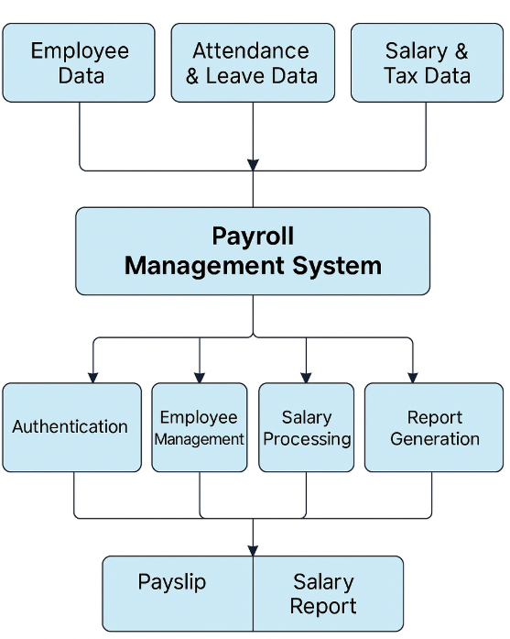

CHAPTER 3: MODULE DESCRIPICTION

The Payroll Management System is composed of several interconnected modules, each responsible for handling specific aspects of payroll operations. These modules work together to ensure seamless processing of employee salary, compliance with statutory regulations, and efficient management of human resource data.

1. Employee Management Module
This module is responsible for storing and managing detailed information about each employee. It includes personal details, job titles, department, date of joining, salary structure, bank details, and contact information. This data serves as the foundation for payroll and related processes.

2. Attendance and Leave Management Module
This module tracks employee attendance and leave records. It integrates with biometric or manual attendance systems to automatically capture working hours and absences. It calculates the number of working days, late entries, early exits, overtime, and leaves taken, all of which directly influence the payroll calculation.

3. Salary Calculation Module
The salary calculation module performs automatic computation of monthly salaries based on the employee’s basic salary, allowances, deductions, and attendance. It factors in components such as overtime pay, leave without pay (LWP), bonuses, and other earnings or deductions. The calculation is rule-based, allowing configuration according to organizational policies.

4. Tax and Statutory Compliance Module
This module ensures that all salary disbursements comply with applicable tax laws and labor regulations. It calculates income tax, professional tax, provident fund (PF), employee state insurance (ESI), and other statutory deductions. It also generates statutory reports and returns required for filing with government authorities.

5. Payslip Generation Module
After salary processing, this module generates digital or printable payslips for each employee. Payslips include a detailed breakdown of earnings, deductions, net pay, and tax information. The system allows secure access for employees to view and download their payslips through a user-friendly interface.

6. Reports and Analytics Module
This module provides a wide range of reports to aid in decision-making and audits. It includes reports on salary disbursement, tax summaries, employee earnings, departmental expenses, and more. The reports can be filtered and exported in various formats for managerial and financial review.

7. User Management and Security Module
This module handles access control and system security. It defines roles and permissions for different types of users, such as HR managers, finance officers, and administrators. It ensures that sensitive payroll data is accessible only to authorized personnel and maintains audit trails for accountability.

8. System Configuration Module
This module allows administrators to customize system settings according to organizational requirements. It includes setting up salary heads, tax slabs, company rules, payroll cycles, holidays, and other configurable elements to align the system with the company’s operations.

CHAPTER 4: CONCLUSION & FUTURE SCOPE

Conclusion
The proposed Payroll Management System offers a reliable, efficient, and secure way to handle payroll operations in any organization. It ensures accuracy, compliance, and ease of use, making it an essential tool for modern HR and finance departments. The system not only improves operational workflows but also enhances the overall employee experience.

Future Scope
The Payroll Management System has vast potential for future enhancements, aiming to increase efficiency, accuracy, and scalability in employee payroll processing. As organizations grow, the need for a robust, intelligent, and integrated payroll solution becomes even more critical. The future developments for this system may include:

- Cloud-Based Deployment: Transitioning to a fully cloud-based solution can offer better accessibility, data backup, and security. This enables HR teams to access payroll data from anywhere, facilitating remote work environments.
- Integration with Biometric and Attendance Devices: Automating the input of attendance and working hours through biometric systems or smart attendance software can improve data accuracy and minimize manual errors.
- AI and Machine Learning Integration: Future versions could use AI to predict salary trends, automate tax calculations, and detect anomalies such as fraudulent claims or salary discrepancies.
- Mobile Application Support: A mobile app version can allow employees to access their payslips, tax forms, and request leaves or changes in personal information directly from their phones.
- Compliance Automation: Enhanced features for automatic updates with local labor laws, tax regulations, and statutory compliance (like PF, ESI, etc.) can ensure continuous legal adherence without manual intervention.
- Multi-language and Multi-currency Support: As organizations expand globally, supporting multiple languages and currencies becomes essential to cater to a diverse workforce.
- Employee Self-Service Portal: Further development of an ESS portal where employees can update their details, download reports, apply for reimbursements, and view benefits could enhance employee satisfaction and reduce HR workload.
- Advanced Analytics and Reporting: Enhanced dashboard functionalities with visual analytics can assist HR managers and executives in making data-driven decisions regarding workforce and compensation planning.
- Security Enhancements: Implementing advanced encryption, role-based access control, and secure audit trails can help safeguard sensitive employee information.
- Integration with ERP Systems: Seamless integration with Enterprise Resource Planning (ERP) solutions like SAP or Oracle can improve workflow across departments, ensuring holistic organizational management.

CHAPTER 5: APPENDIX A - SOURCE CODE

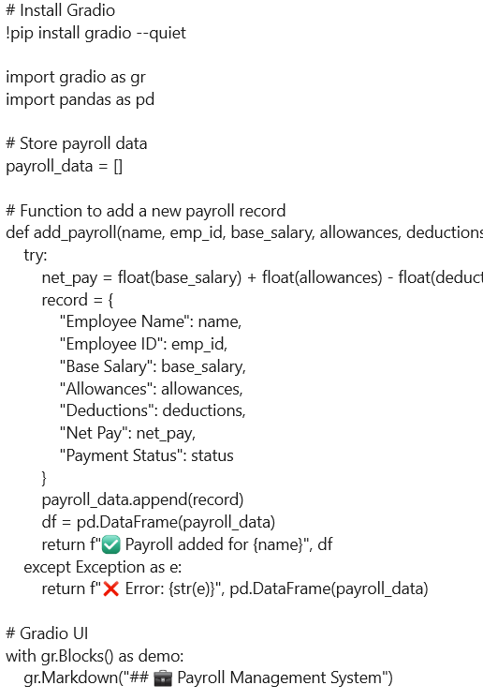

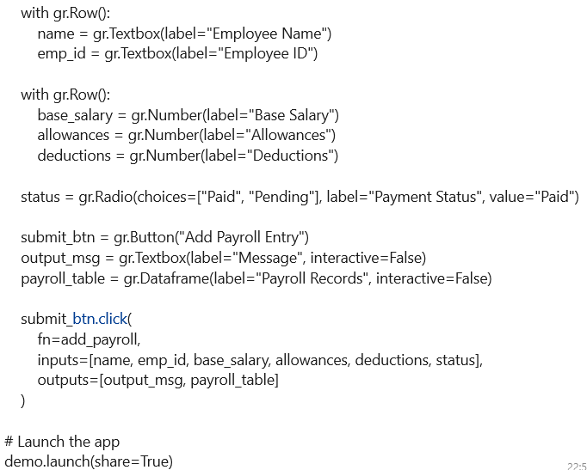

APPENDIX B - SCREENSHOTS
STEP 1:

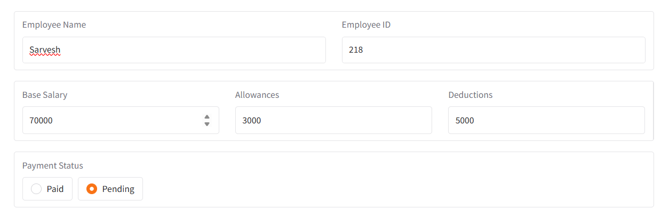

STEP 2:
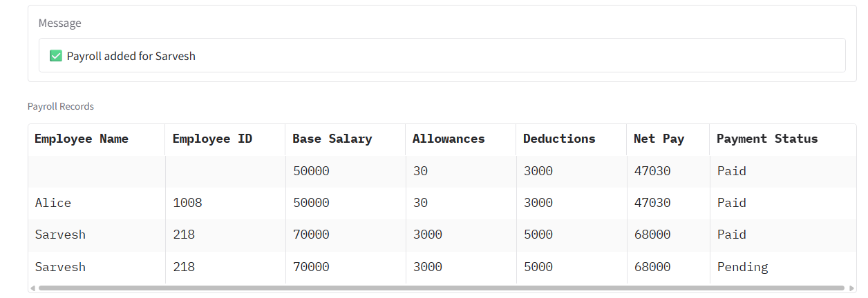

STEP 3:
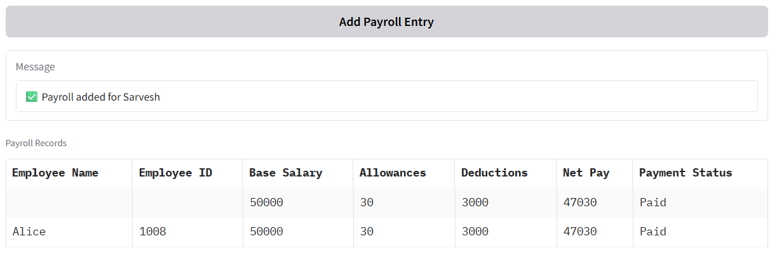

Author/Organization. (Year, Month Day). Title of webpage. Site name. URL
Example:
W3Schools. (n.d.). SQL Tutorial. W3Schools. https://www.w3schools.com/sql/
MLA:
“Payroll system.” Website Name, Publisher (if different from website name), Date of publication, URL. Accessed Day Month Year.
Example:
“SQL Tutorial.” W3Schools, https://www.w3schools.com/sql/. Accessed 17 May 2025.
IEEE:
[2] W3Schools, "SQL Tutorial," https://www.w3schools.com/sql/, accessed May 17, 2025.

